READING GROUP 2. Excerpts from: Neck, H.M. & Greene, P.G. (2011). Entrepreneurship education: Known worlds and new frontiers. Journal of Small Business Management, 49(1), 55-70. Reproduced with lead author’s permission.

Abstract
We explore three “worlds” that entrepreneurship educators generally teach in and introduce a new frontier where we discuss teaching entrepreneurship as a method. The method is a way of thinking and acting, built on a set of assumptions using a portfolio of techniques to create. It goes beyond understanding, knowing, and talking and requires using, applying, and acting. At the core of the method is the ability for students to practice entrepreneurship and we introduce a portfolio of practice-based pedagogies. These include starting businesses as coursework, serious games and simulations, design-based thinking, and reflective practice.

Introduction
The current approaches to entrepreneurship education are based on a world of yesterday—a world where precedent was the foundation for future action, where history often did predict the future. Yet, entrepreneurship is about creating new opportunities and executing in uncertain and even currently unknowable environments. Entrepreneurship and entrepreneurship education have more relevance today than ever before.

The purpose of this paper is to present a framework for teaching in a new world. We advance the concept of teaching entrepreneurship as a method, which is in contrast to the current ways—the known worlds—in which we are currently teaching entrepreneurship. We are not proposing a particular pedagogy. If anything, we would firmly fall in Forest and Peterson’s (2006) andragogy camp anyway. On the contrary, we are proposing an entirely different approach to teaching entrepreneurship. We are proposing an overarching framework for teaching entrepreneurship that will require many different approaches to teaching and learning—some of which have not yet been discovered or created.

We are proposing that teaching entrepreneurship requires teaching a method. The method is teachable, learnable, but it is not predictable. The method is people dependent but not dependent on a type of person. The entrepreneurship method goes beyond understanding, knowing, and talking and demands using, applying, and acting. Most importantly the method requires practice. Entrepreneurship requires practice. Learning a method, we believe, is often more important than learning specific content. In an ever-changing world, we need to teach methods that stand the test of dramatic changes in content and context. We introduce this method in light of other current approaches to teaching entrepreneurship.

The Known Worlds of Entrepreneurship Education

We present three different approaches used to teach entrepreneurship. Some educators rely on one approach, whereas others incorporate two or even all approaches. Though it is tempting to think our worlds represent the evolution of the field, we do not think of them strictly in chronological order and recognize that each of these approaches is being used in classrooms today.

The Entrepreneur World

In this world, the entrepreneur reigns supreme with almost superhero characteristics. The entrepreneur is the champion in this world. On the delivery side, as teachers, we use a variety of entrepreneurial assessments, self-examinations, the “do you have the right stuff” approach. We probe for those characteristics the early research suggested were important, such as locus of control or need for achievement. Many of these are interesting and valid measures but not necessarily precise for identifying entrepreneurs.

The entrepreneur world is heavily influenced by a lecture teaching methodology, basically a stand-and-deliver approach. However, we combine this with the use of many guest speakers, selected with a precise list of criteria reflecting again in this world’s particular definition of “entrepreneur” and “success.”
The pedagogical implications of the entrepreneur world are a description of the entrepreneur, neatly fitting into an “observe, describe, and measure” approach, supporting categorizations and some correlations but not able to go beyond (Christensen and Carlile 2009). In some sense, our students taught in this world see entrepreneurship as a box in which they either fit or do not. Their concern is that they do not have the right stuff/characteristics to be an entrepreneur. As teachers, our choices of entrepreneurial illustrations set up role models and our students often do not see a reflection of themselves. The ironic part is that with all this description, picking the winners does not get any easier.

The Process World
The influence of strategy scholars working in the field coupled with calls for more rigorous and methodically sound studies led scholars to operationalize entrepreneurship as a process with greater emphasis on the organizational level of analysis. The process view extends the reach of entrepreneurship from firm creation to firm exit; thus, there is increased attention given to capital markets, resource allocation, performance, and growth. The process research results found their way into the classroom, and textbooks today take a more process-oriented approach. The process is presented and taught in a linear fashion as one of identifying an opportunity, developing the concept, understanding resource requirements, acquiring resources, implementation, and exit (Morris 1998).

We refer to the process world as one of planning and prediction. The analytical approach of teaching opportunity evaluation, feasibility analysis, business planning, and financial forecasting is the cornerstone for most entrepreneurship curricula today. Business plan writing and the case method in this world are the preferred pedagogies. In a field where we argue that there are no right answers, the process world, from an education perspective, is the closest we can get.

To complement the planning portion of core entrepreneurship courses, the case method is used so students can learn about the various decision options faced by entrepreneurs. The case study is admittedly a powerful tool that allows the center of learning to be with the students; however, the majority of faculty are never adequately trained in the case method. Teaching using the case method takes an extraordinary amount of time—both in prep as well as in mastery.

The process world in our view is one of prediction. It focuses on a linear process that if followed correctly, will increase the likelihood of venture success. The steps in the process are generally introduced in introductory entrepreneurship courses, then electives are offered to delve deeper into particular steps. The problem is that entrepreneurship is neither linear nor predictable, but it is easy to teach as if it were.

The Cognition World
In this world, we are again focusing on the entrepreneur or the entrepreneurial team but in a quite different way. This newer focus on the person is in a more dynamic way that recognizes the potential for learning how to think entrepreneurially. The more helpful question is “how do people think entrepreneurially?” This is a much more useful construct to guide our educational and research activities in the field, recognizing the great diversity in the ways people can be entrepreneurs.
So, what and how do we teach in this world? We pay attention to different things, including the decision to become an entrepreneur and how to understand that decision. We investigate the entrepreneur and most certainly now include the team. We spend more time on discovery, specifically on the identification and exploitation of opportunities, and we explore what we believe to be the central question of this world: how do people think entrepreneurially. Overall, in this world, we are focusing on entrepreneurial decisions and we do it by discussing the role of expert scripts, heuristics, and schema, leading to the construction of entrepreneurial mental models. The cognition world is growing in popularity because it recognizes the importance of the mind and the dynamic approach to learning how to think entrepreneurially.

New Frontiers: Entrepreneurship as a Method

Why do we support entrepreneurship as a method? Because a process implies that you will get to a specific destination. Entrepreneurship is often thought of as a process—a process of identifying an opportunity, understanding resource requirements, acquiring resources, planning, and implementing. However, the word “process” assumes known inputs and known outputs as in a manufacturing process. A process is quite predictable. Entrepreneurship is not predictable. On the other hand, a method represents a body of skills or techniques; therefore, teaching entrepreneurship as a method simply implies that we are helping students understand, develop, and practice the skills and techniques need for productive entrepreneurship.

Figure 1 contrasts teaching entrepreneurship as a process and a method.

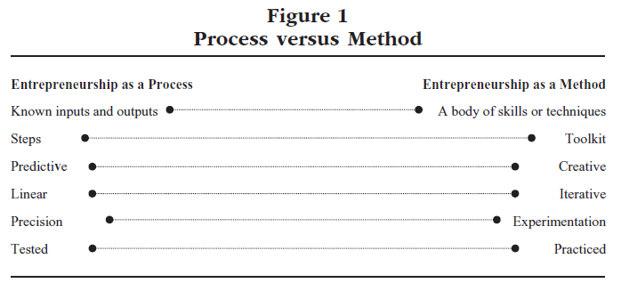

Teaching entrepreneurship as a method requires going beyond understanding, knowing, and talking; it requires using, applying, and acting. Entrepreneurship requires practice. Learning a method may be more important than learning content. In an ever-changing world, we need to teach methods that stand the test of dramatic changes in content and context

Approaching entrepreneurship as a method means teaching a way of thinking and acting built on a set of assumptions using a portfolio of techniques to encourage creating. The method forces students to go beyond understanding, knowing, and talking. It requires using, applying, and acting. The method requires practice. Therefore, our underlying assumptions of the method include the following:

(1) Applies to novice and experts: the assumption is that the method applies across student populations and works regardless of experience level. What is important is that each student understands how he or she views the entrepreneurial world and his or her place in it. It represents the foundation of the method.

(2) The method is inclusive, meaning that the definition of entrepreneurship is expanded to include any organization at multiple levels of analysis. Therefore, success is idiosyncratic and multidimensional.

(3) The method requires continuous practice. The focus here is on doing, then learning, rather than learn then do. As a result a reflective practice component is incredibly important to learning.

(4) The method is for an unpredictable environment.

Conclusions

Table 1 summarizes the known worlds (entrepreneur, process, cognition) that we teach in today as well as the new frontier presented here— entrepreneurship as a method. Our purpose was to acknowledge that we teach in several different worlds. Many teach in more than one world, but the environment for entrepreneurship is changing whereas education for entrepreneurship is not. We are living in a world characterized by increasingly greater levels of uncertainty and even unknowability. We are advocating for an entrepreneurship method approach for three reasons: First, entrepreneurship education is incredibly important, but current, mainstream approaches are dated. Second, real-world experience contributes significantly to learning, but sometimes, the cost of failing in the real world is too high. Finally, and because of points 1 and 2, entrepreneurship within a formal education structure requires a new approach based on action and practice.

The method is people-dependent but not dependent on a type of person. The entrepreneurship method goes beyond understanding, knowing, and talking and demands using, applying, and acting. Most importantly, the method requires practice. Entrepreneurship requires practice. Learning a method, in our opinion, is often more important than learning specific content. In an ever-changing world, we need to teach methods that stand the test of dramatic changes in content and context. At the end of the day, perhaps we do not teach entrepreneurship the discipline. Perhaps we teach a method to navigate the discipline.
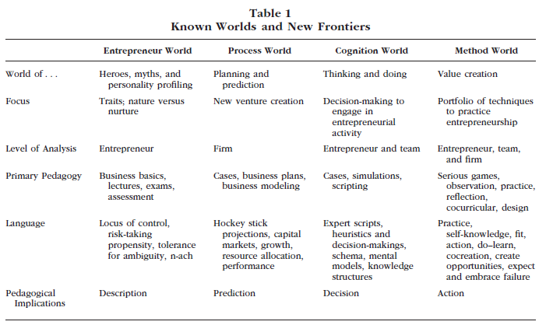

Selected References

Christensen, C. M., and P. R. Carlile (2009). “Course Research: Using the Case Method to Build and Teach Management Theory,” Academy of Management Learning & Education 8(2), 240–251.

Forest, S., and T. Peterson (2006). “It’s Called Andragogy,” Academy of Management Learning & Education 5(1), 113–122.

Morris, M. H. (1998). Entrepreneurial Intensity: Sustainable Advantages for Individual, Organizations, and Societies. Westport, CT: Quorum.

